# Initial Conditions GUI

## Purpose:

This GUI accepts user inputs of initial conditions of their quadcopter vehicle for use in the simulation. Once all of the fields are populated, the interface saves a MATLAB “structure” that contains all the parameters needed to run the simulation. A structure is a data type that gives us a way to combine multiple types of information under a single variable name that can easily be passed around the MATLAB environment. The Initial Conditions GUI can be seen below in Figure 1.

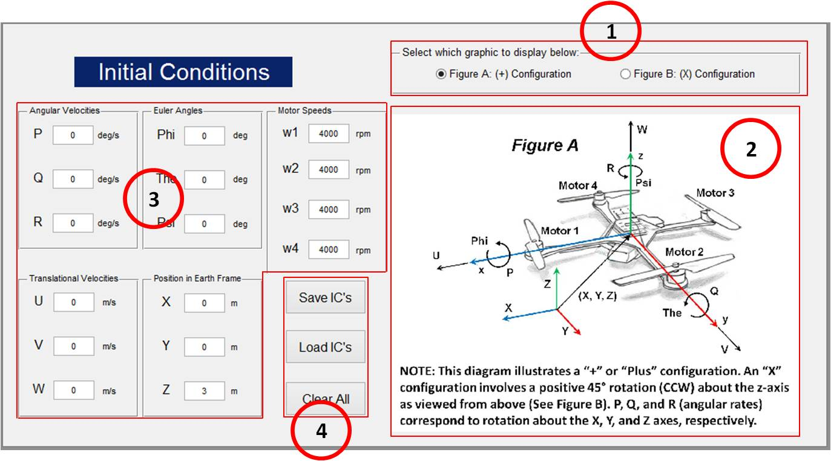

*Figure 1. Initial Conditions GUI*

## Description:

1. Graphic display toggle: Figure A displays the initial condition parameters on a quadcopter vehicle in a “+” configuration. This configuration has Motor 1 located directly on the x-axis and Motor 2 located directly on the y-axis. Figure B displays the same vehicle except in an “X” configuration, where the x-axis is located directly between Motors 1 and 2. This involves a positive 45° rotation (CCW) of the coordinate system about the z-axis as viewed from above. Toggle between Figure A and B to see the differences visually.
2. Display a graphic showing the differences in the “+” and “X” configurations by toggling between Figure A and B.
3. Initial Condition inputs for:
   * Angular Velocities (P, Q, R) in degrees/second:
     + Initial Roll rate, pitch rate, and yaw rate respectively.
   * Euler angles (Phi, Theta, Psi) in degrees:
     + Initial orientation of the quadcopter vehicle with respect to the x, y, and z axes (roll, pitch, yaw) of the inertial frame.
   * Translational Velocities (U, V, W) in meters/second:
     + Initial velocities of the body in the x, y, and z directions of the body frame.
   * Position in Inertial Frame (meters):
     + Initial position of the body in the inertial frame. The inertial frame is a fixed set of axes that are used as a reference and don’t accelerate or rotate.
   * Motor speeds (rpm):
     + Initial speeds of the 4 motors on the vehicle. For example, if the vehicle is to start on the ground with motors off (w1 = w2 = w3 = w4 = 0 rpm). Or, if the vehicle is to start in a hover (w1 = w2 = w3 = w4 ≈ 4000 rpm for our quadcopter. You can calculate this for your vehicle once you have all of your parameters measured.).
4. Once all of the initial condition fields are populated, the “Save IC’s” button is used to save the conditions inside a MATLAB structure. Also, if they already have an IC structure saved the user can click “Load IC’s”, select the desired structure and the GUI will populate the fields with the loaded parameters. This is useful because if the user wishes to change only 1 parameter of their IC structure they don’t need to enter everything again.

## Graphics:

**Figure A: (+) Configuration**

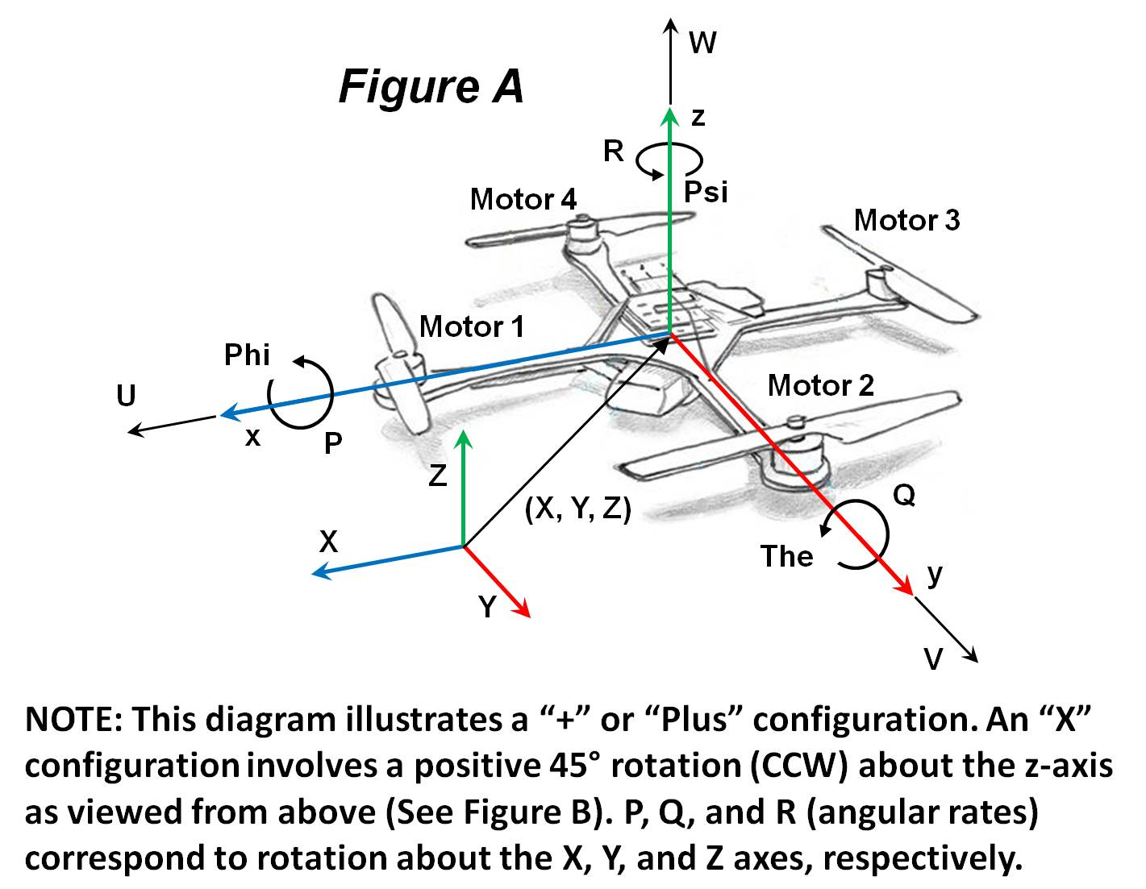

**Figure B: (X) Configuration**

